**DAY-1**

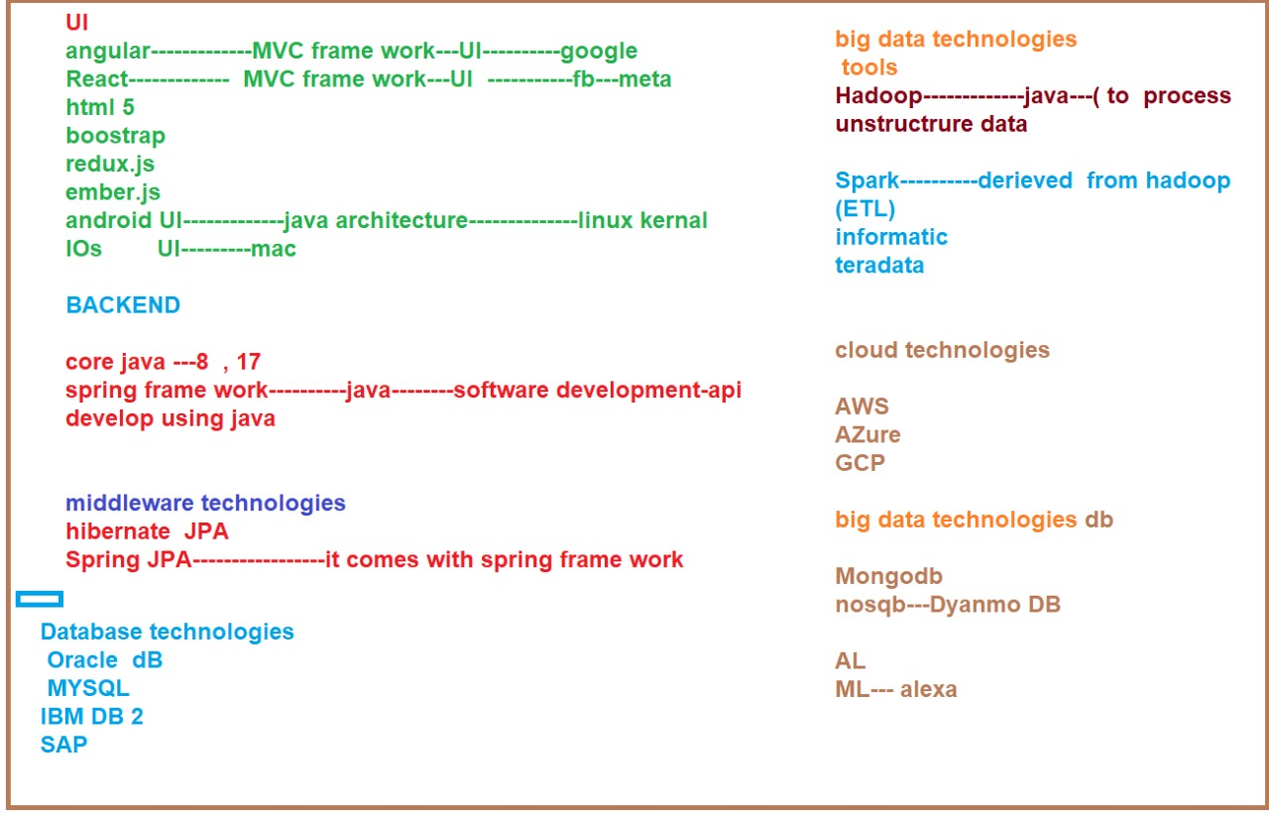

<https://www.w3schools.com/js/js_json_intro.asp>

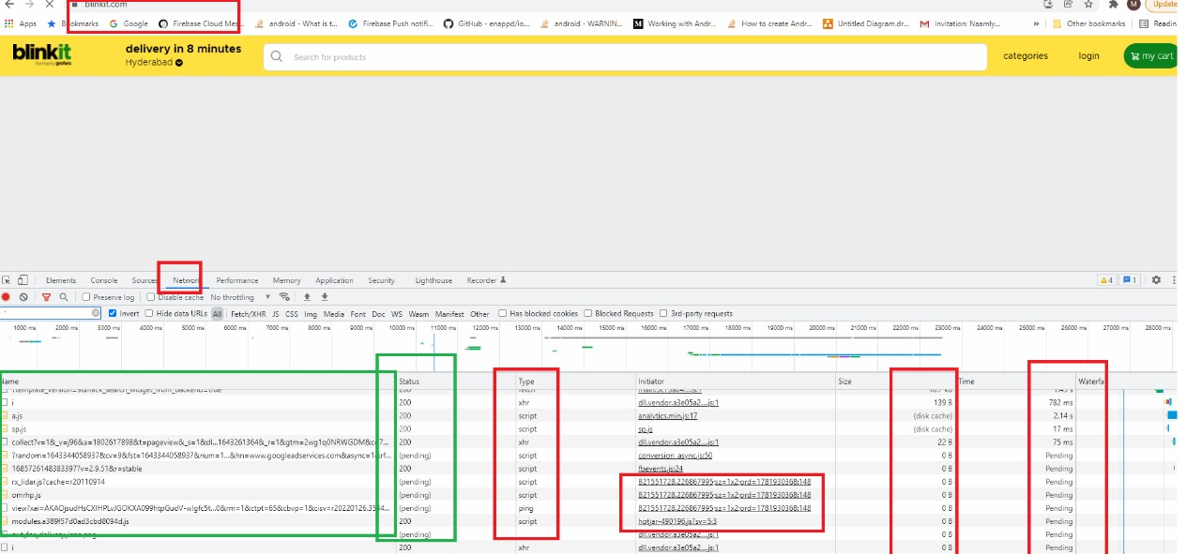

GIT Reference Link:

<https://github.com/checkcc/capegemine2022.git>

Git Uploading Steps:

1 .git clone https://github.com/checkcc/capegemine2022.git

2. git add .

3. git status

4.git commit -m "my day1 java prgs"

5. git push origin main or master

**DAY-2**

OPERATORS IN JAVA :

<https://www.slideshare.net/Thenmurugeshwari/operators-in-java>

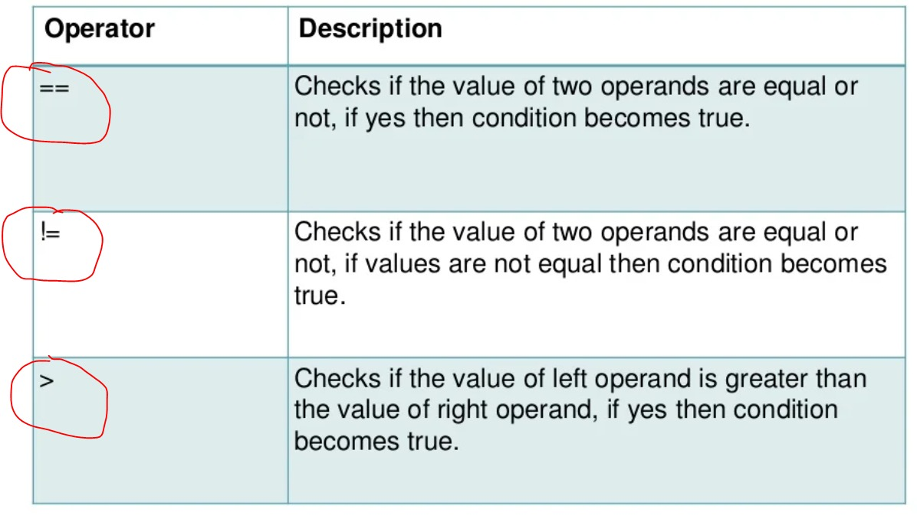

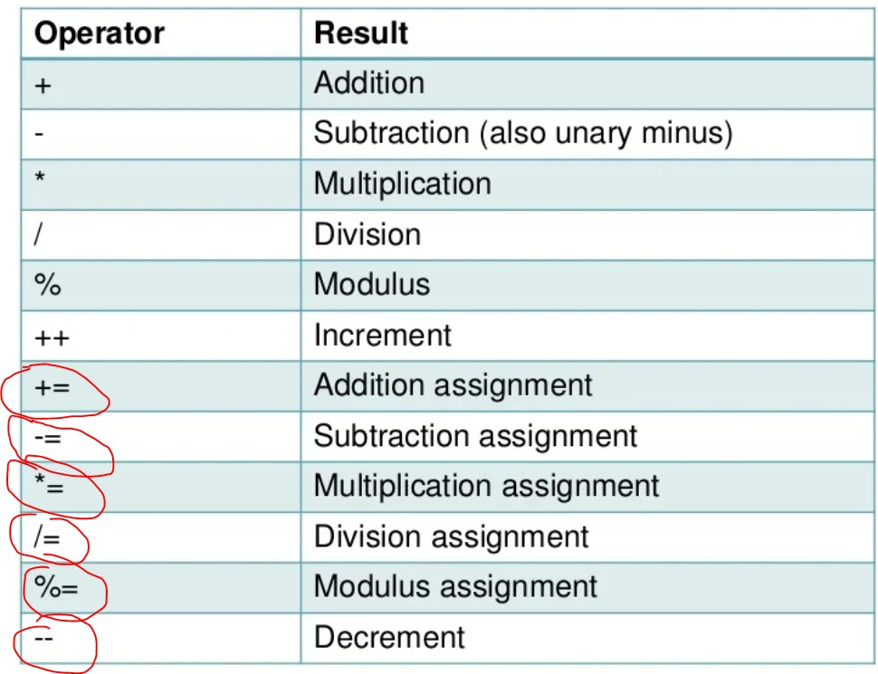

ACCESS MODIFIERS IN JAVA:

<https://www.slideshare.net/HrithikShinde/access-specifiersmodifiers-in-java>

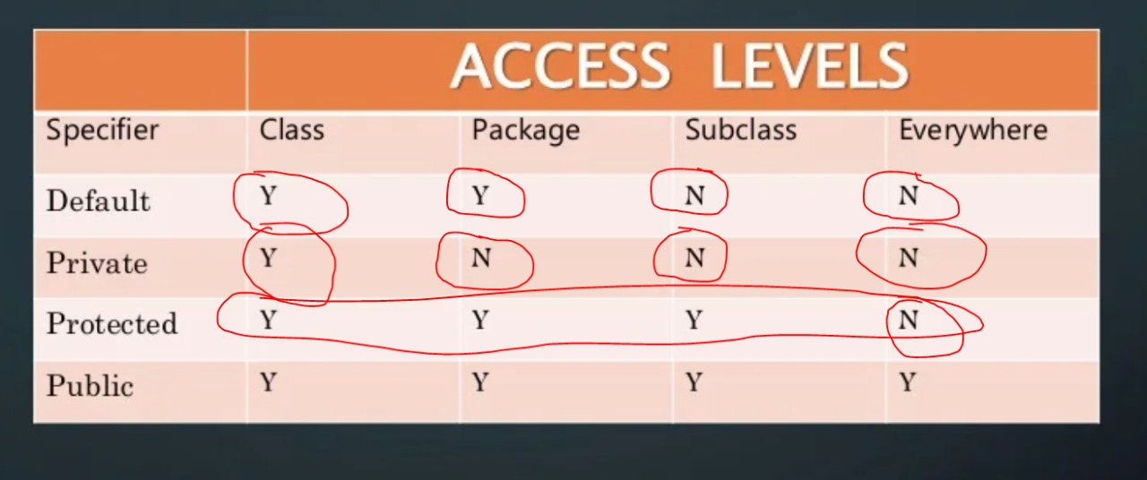

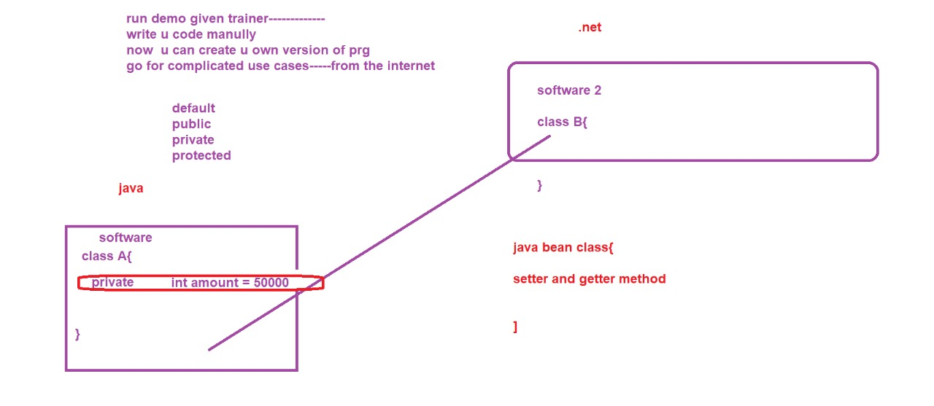

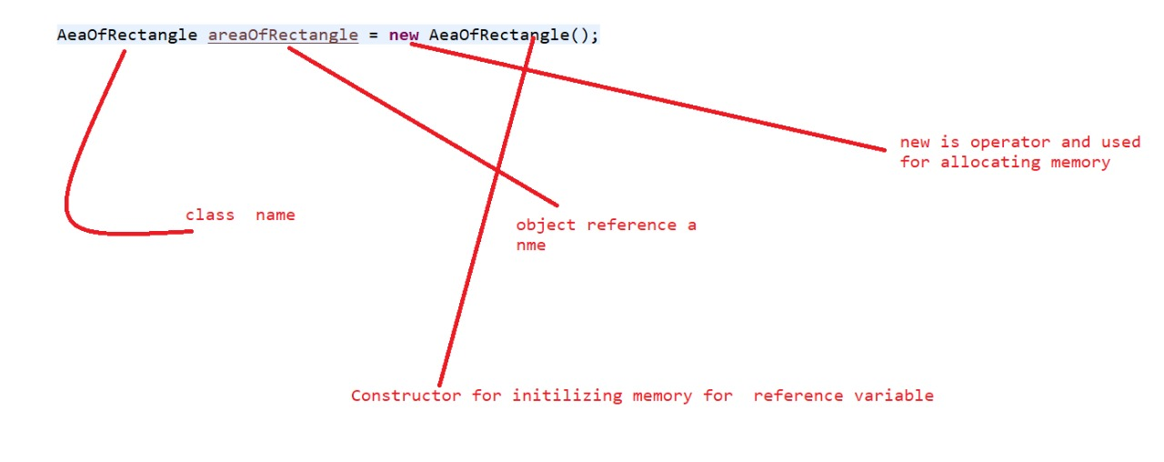

<https://www.youtube.com/watch?time_continue=1&v=HVsySz-h9r4&feature=emb_logo>

Git

<https://docs.oracle.com/javase/tutorial/index.html>

<https://www.youtube.com/watch?v=qQdfyb2KRko&feature=emb_logo>

First Java Program

<https://www.youtube.com/watch?v=bqPIWlnjWbA&feature=emb_logo>

Data types

https://www.youtube.com/watch?v=6Ocu3IHuBCk If Else

<https://www.youtube.com/watch?v=6djggrlkHY8&feature=emb_logo>

Loops

<https://www.youtube.com/watch?v=RVRPmeccFT0>

Switch Statements

<https://www.youtube.com/watch?v=Pa0lUMWmmm0>

Operators

<https://www.youtube.com/watch?v=_NfwcH5zKpA&feature=emb_logo>

Array

<https://www.youtube.com/watch?v=L06uGnF4IpY>

<https://www.youtube.com/watch?v=-HafzawNlUo>

OOPS

<https://www.youtube.com/watch?v=V-PQvKUtSY8>

Classes and Objects

<https://www.youtube.com/watch?v=YqBVgUh64Ks>

Constructor

<https://www.youtube.com/watch?time_continue=9&v=Ruy-yzj-JG8&feature=emb_logo>

Modifiers

<https://www.youtube.com/watch?v=eEujVn-ZTLE&feature=emb_logo>

Packages

<https://www.youtube.com/watch?v=4VBdNbWeTZw&feature=emb_logo>

Encapsulation

<https://www.youtube.com/watch?v=RcIsb9iFKH8&feature=emb_logo>

Abstract Classes

<https://www.youtube.com/watch?v=_9R_in_7cT4>

Inheritance

<https://www.youtube.com/watch?v=0xw06loTm1k&feature=emb_logo>

Polymorphism

<https://www.youtube.com/watch?v=_NfwcH5zKpA&feature=emb_logo>

Arrays

<https://www.youtube.com/watch?time_continue=1&v=r3DBIDyzLUI&feature=emb_logo>

Strings

<https://www.youtube.com/watch?v=7WsU9SyS-uI&feature=emb_logo>

StringBuilder, StringBuffer

<https://www.youtube.com/watch?v=qRCEdWQ0f4Q>

Static

<https://www.youtube.com/watch?v=msXJVIecGp0>

Non static and Static

<https://www.youtube.com/watch?v=AmRjm4Cksmo>

Anonymous Object

<https://www.youtube.com/watch?v=Ggjxn8Q9VuE>

Interface

<https://www.youtube.com/watch?v=XKEBjp1k8cQ>

Wrapper Classes

<https://www.youtube.com/watch?v=O6IkXdRVp6I>

Boxing and UnBoxing

<https://www.youtube.com/watch?v=8WTVLa1Xtsk&list=PLsyeobzWxl7rS9B2K1l--VDpCn41gijnV>

Exception Handling

<https://www.youtube.com/watch?v=5NOLuoG6fcQ&list=PLsyeobzWxl7oJj5BXYF088REBm-K4c_SR>

Collections

<https://www.youtube.com/watch?v=XUTJZZDZG8k&list=PLzS3AYzXBoj8XCaW6-o73-FkvZPMas41L>

https://www.youtube.com/watch?v=mQ9uxTWZCXA&list=PLFGoYjJG_fqooGAq7UKpkXb8l4xjyEQUr

https://www.youtube.com/watch?v=0xrhqxTOphI

https://www.youtube.com/watch?v=W5gnVp1NUNU

<https://www.youtube.com/watch?v=kD_HqZP8MLY>

IO and File Handling

<https://www.youtube.com/watch?v=QfGVi89AV4c>

<https://www.youtube.com/watch?v=OUnDCLhkh_E&list=PLcJ7Ar5qZeeH01O-Pe7aHLQ9UXEp47_Lw>

<https://www.youtube.com/watch?v=3YRahx2ltSg>

<https://www.youtube.com/watch?v=waXvGUEjTTs>

<https://www.youtube.com/watch?v=y_YxwyYRJek&list=PLsyeobzWxl7rU7Jz3zDRpqB-EODzBbHOI>

JDBC

<https://www.youtube.com/watch?v=8-iQDUl10vM&list=PLEAQNNR8IlB4R7NfqBY1frapYo97L6fOQ>

<https://www.youtube.com/watch?v=BOUMR85B-V0&list=PLhs1urmduZ2-yp3zID5rMEmXDETN8xvMo>

<https://www.youtube.com/watch?v=grEKMHGYyns>

Java 8 new features

<https://www.youtube.com/watch?v=gpIUfj3KaOc&list=PLqq-6Pq4lTTa9YGfyhyW2CqdtW9RtY-I3>

<https://www.youtube.com/watch?v=a8jvxBbswp4&list=PLqq-6Pq4lTTa9YGfyhyW2CqdtW9RtY-I3&index=10>

<https://www.youtube.com/watch?v=QRwG9X9l6xI&list=PLsyeobzWxl7qbvNnJKjYbkTLn2w3eRy1Q>

<https://www.youtube.com/watch?v=4e_RsZWdiSc>

INHERITANCE :

<https://www.javatpoint.com/inheritance-in-java>

**DAY-3**

INHERITANCE :

Terms used in Inheritance

Class: A class is a group of objects which have common properties. It is a template or blueprint from which objects are created.

Sub Class/Child Class: Subclass is a class which inherits the other class. It is also called a derived class, extended class, or child class.

Super Class/Parent Class: Superclass is the class from where a subclass inherits the features. It is also called a base class or a parent class.

Reusability: As the name specifies, reusability is a mechanism which facilitates you to reuse the fields and methods of the existing class when you create a new class. You can use the same fields and methods already defined in the previous class.

Inheritance represents the IS-A relationship which is also known as a parent-child relationship.

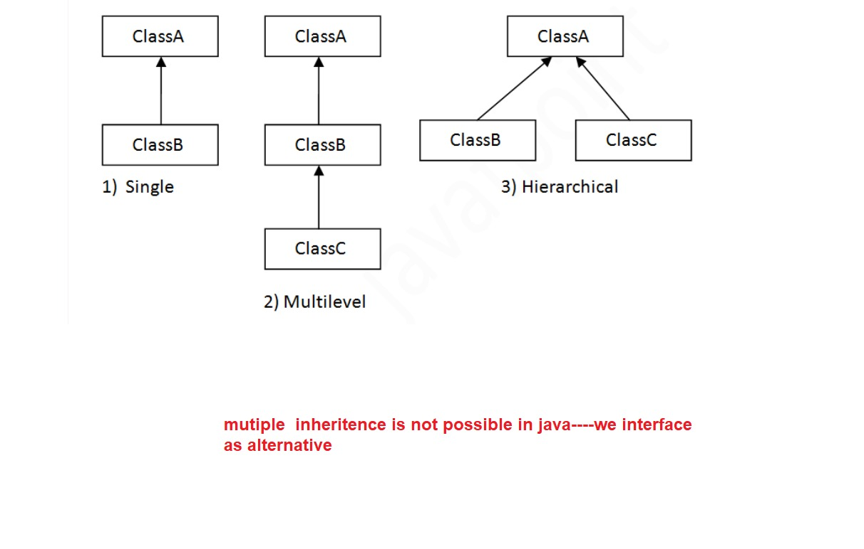

<https://www.geeksforgeeks.org/what-is-has-a-relation-in-java/>

Association is the relation between two separate classes which establishes through their Objects.

Composition and Aggregation are the two forms of association. In Java,

a Has-A relationship is otherwise called composition. It is additionally utilized for code reusability in Java. In Java, a Has-A relationship essentially implies that an example of one class has a reference to an occasion of another class or another occurrence of a similar class.

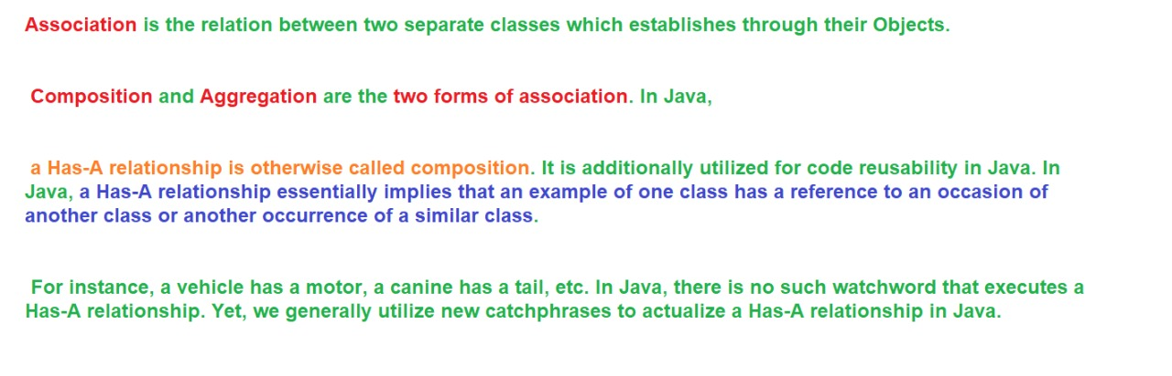

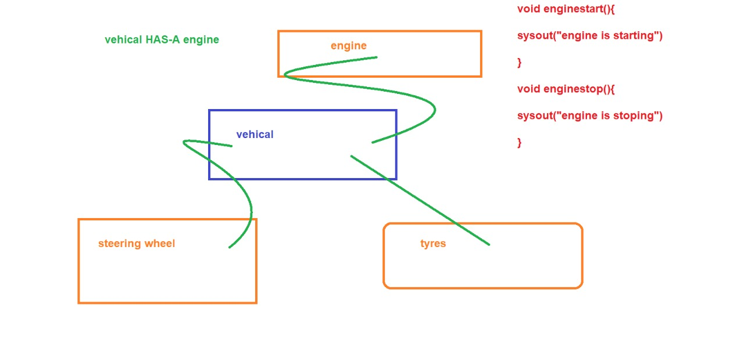

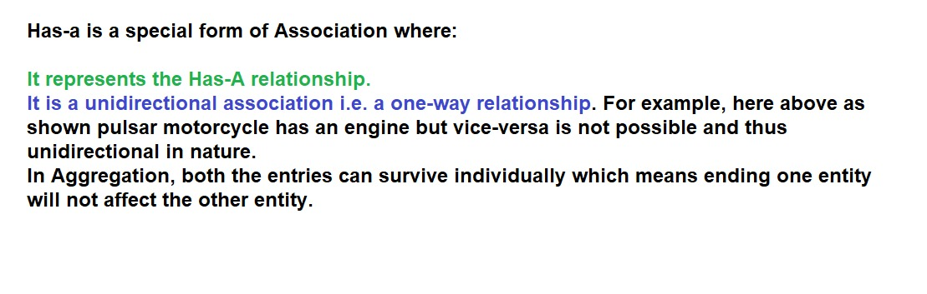

<https://www.geeksforgeeks.org/what-is-has-a-relation-in-java/>

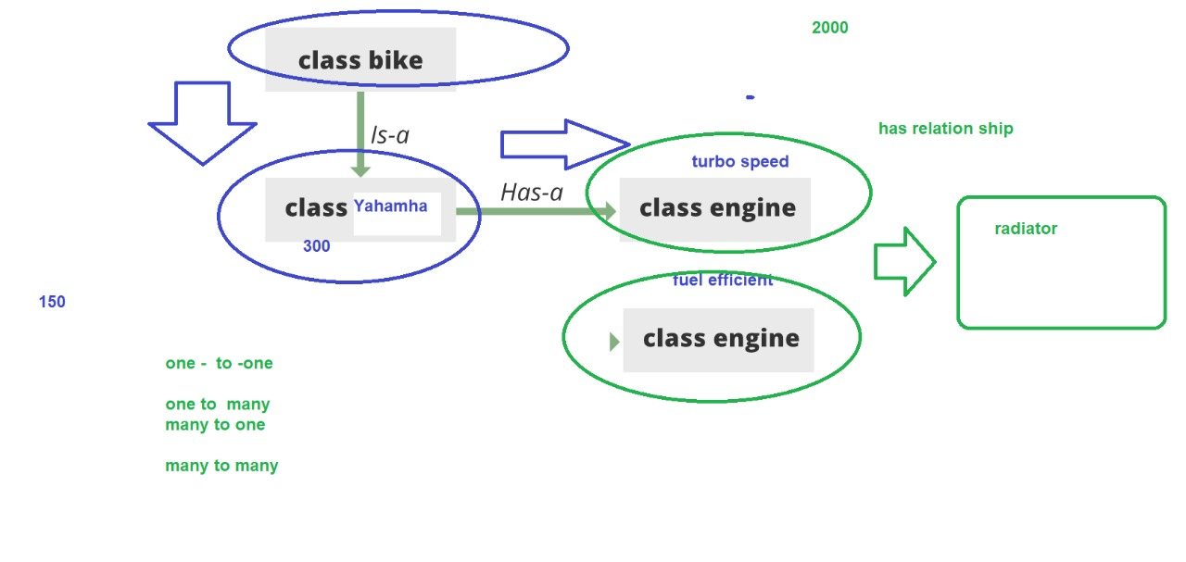

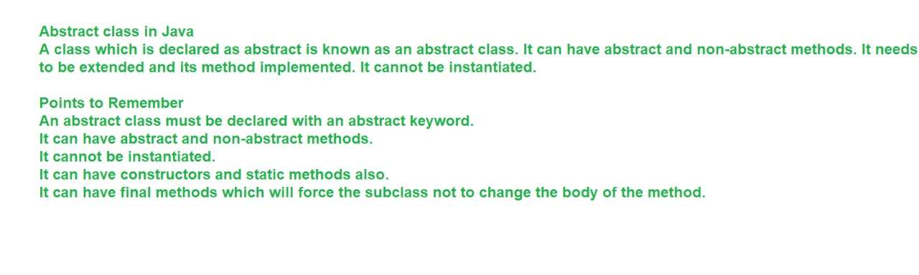

diamond shape problem:

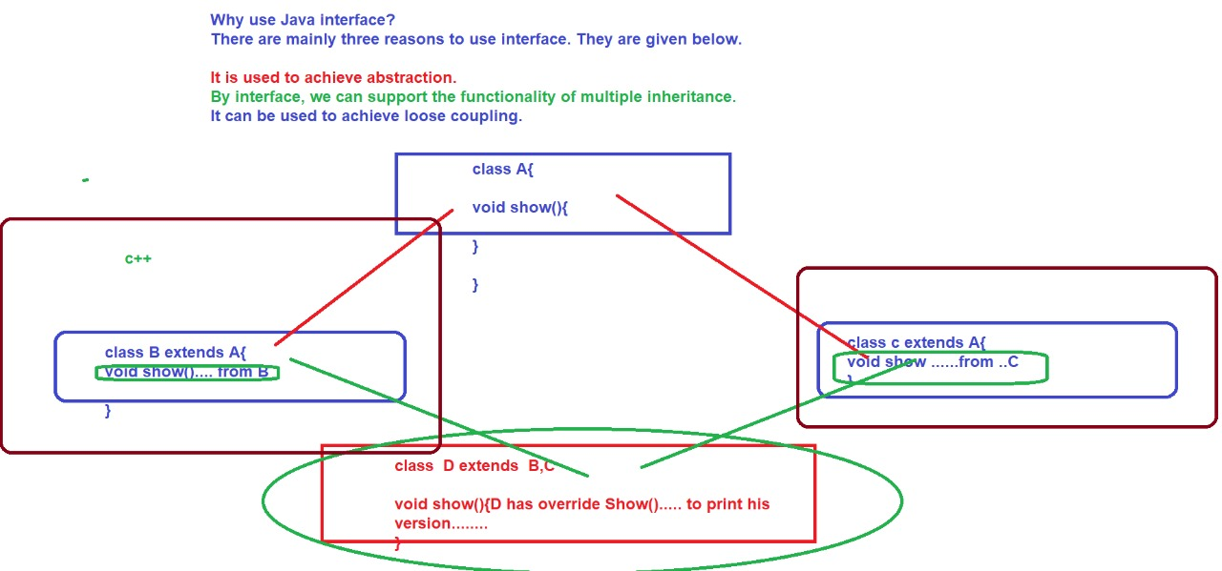

<https://www.slideshare.net/HarisBinZahid/abstract-class-and-interface-49451395>

<https://www.w3schools.com/java/java_interface.asp>

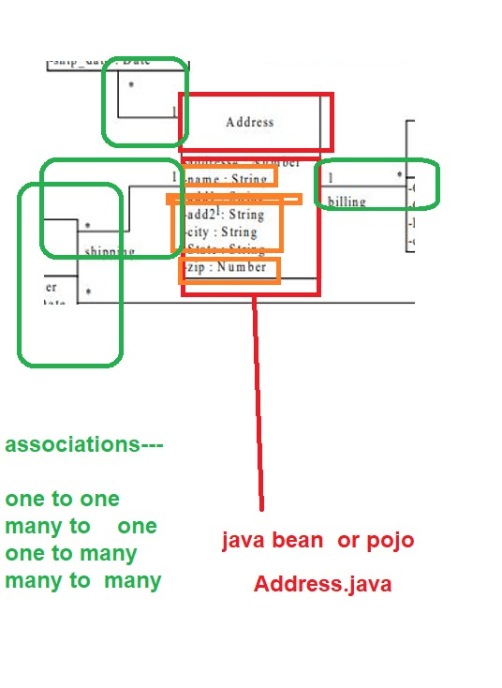

**DAY-4**

INTERFACES :

[Interface in Java - Javatpoint](https://www.javatpoint.com/interface-in-java#:~:text=An%20interface%20in%20Java%20is,static%20constants%20and%20abstract%20methods.&text=There%20can%20be%20only%20abstract,and%20multiple%20inheritance%20in%20Java)

an interface is different from a class in several ways, including −

You cannot instantiate an interface.

An interface does not contain any constructors.

All of the methods in an interface are abstract.

An interface cannot contain instance fields.

The only fields that can appear in an interface must be declared both static and final.

An interface is not extended by a class; it is implemented by a class.

An interface can extend multiple interfaces.

EXCEPTION HANDLING:

<https://www.javatpoint.com/exception-handling-in-java>

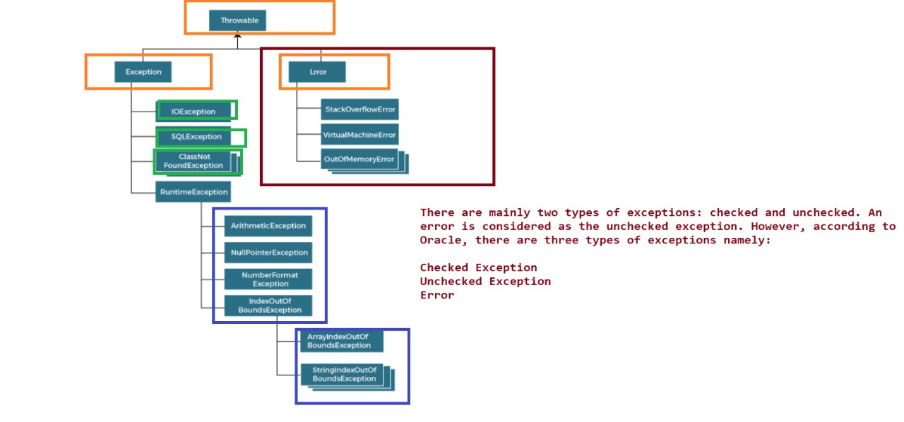

list of exceptions :

ArithmeticException

It is thrown when an exceptional condition has occurred in an arithmetic operation.

ArrayIndexOutOfBoundsException

It is thrown to indicate that an array has been accessed with an illegal index. The index is either negative or greater than or equal to the size of the array.

ClassNotFoundException

This Exception is raised when we try to access a class whose definition is not found

FileNotFoundException

This Exception is raised when a file is not accessible or does not open.

IOException

It is thrown when an input-output operation failed or interrupted

InterruptedException

It is thrown when a thread is waiting, sleeping, or doing some processing, and it is interrupted.

NoSuchFieldException

It is thrown when a class does not contain the field (or variable) specified

NoSuchMethodException

It is thrown when accessing a method which is not found.

NullPointerException

This exception is raised when referring to the members of a null object. Null represents nothing

NumberFormatException

This exception is raised when a method could not convert a string into a numeric format.

RuntimeException

This represents any exception which occurs during runtime.

StringIndexOutOfBoundsException

It is thrown by String class methods to indicate that an index is either negative or greater than the size of the string

<https://www.geeksforgeeks.org/types-of-exception-in-java-with-examples/>

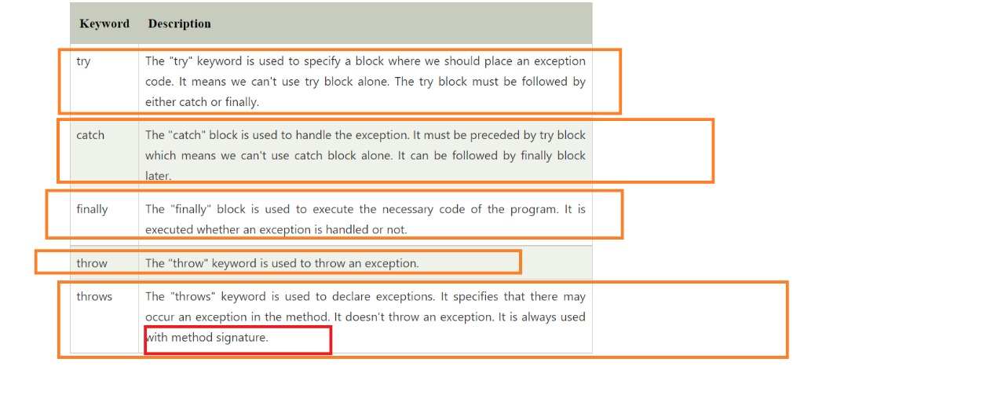

<https://www.geeksforgeeks.org/g-fact-32-user-defined-custom-exception-in-java/>

DAY-5

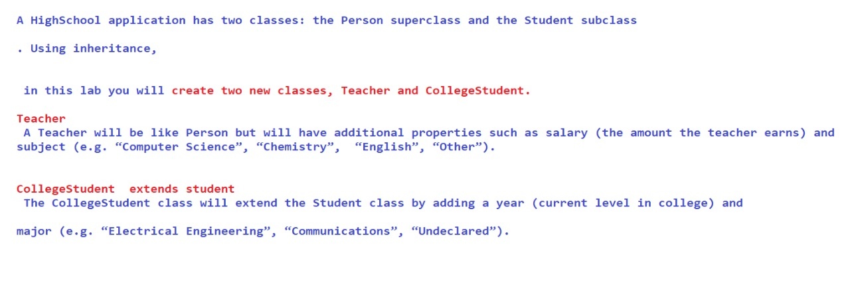

<https://docs.oracle.com/javase/8/docs/api/java/lang/String.html>

<https://www.journaldev.com/797/what-is-java-string-pool>

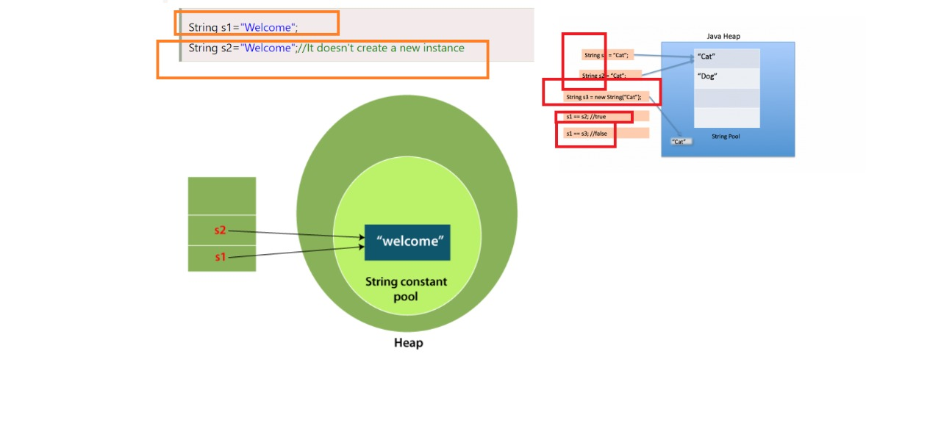

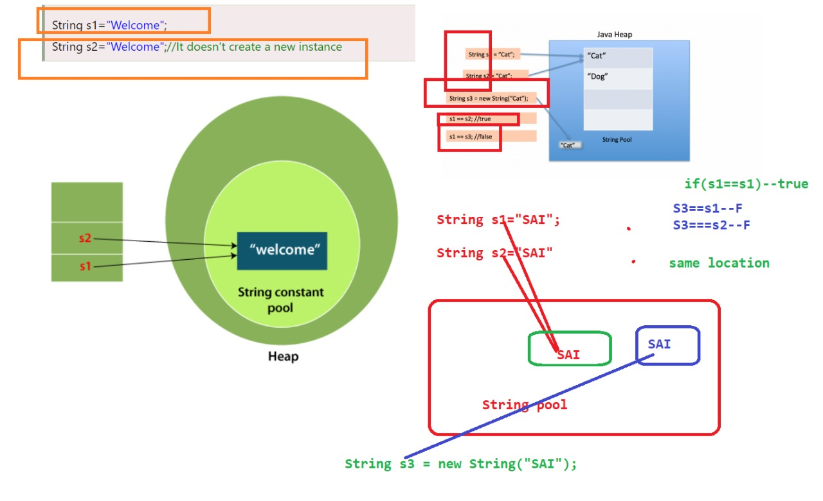

DAY-6

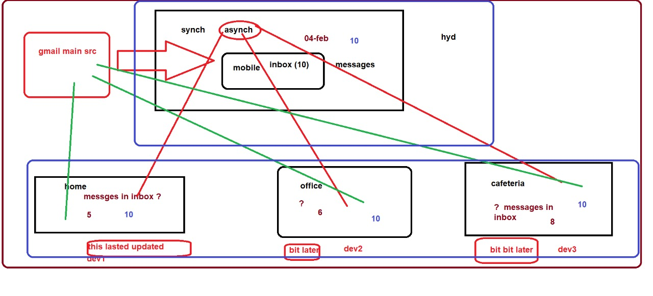

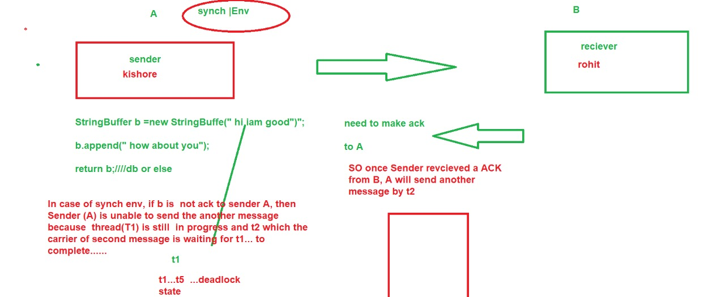

<https://www.baeldung.com/java-wrapper-classes>

<https://www.slideshare.net/tuhinkundu007/threads-in-java-45202167>

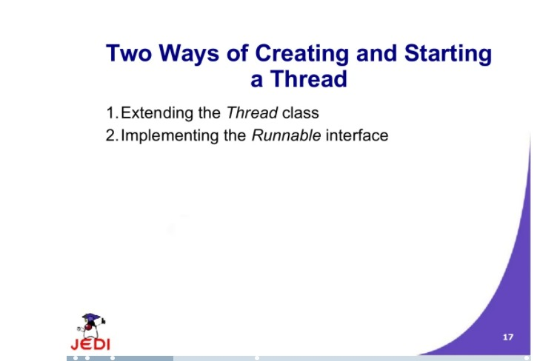

<https://www.slideshare.net/babu4b4u/javathread>

